Centro Studi Opera Omnia Luigi Boccherini
November 10-12, 2017 | Lucca, Italy
CONFERENCE | PROFESSOR REICHA: PRACTICE AND LEGACY OF A COMPOSER-TEACHER
“LOUISE DUMONT FARRENC and the LEGACY of ANTON REICHA”
Mary Ellen Haupert, Ph.D.
Professor of Music
Viterbo University | La Crosse, WI, USA

I. Introduction
Anton Reicha (1770 – 1836) was a revered theorist, composer, and teacher. His work as a teacher ensured that his innovative theories, rooted in the Viennese Classical tradition, would flourish in the hands of his esteemed students. In company with Franz Liszt, Hector Berlioz, Charles Gounod, and Cesar Franck, Louise Dumont Farrenc (1804–1875) would gain her professional footing under Reicha’s tutelage, yet would forge her impressive career as a performer, composer, and teacher in a style more closely-aligned with that of her teacher.

Reicha students Liszt, Berlioz, and Franck would establish themselves as composers, while Farrenc would succeed her mentor as a faculty member at the Conservatoire – teaching, performing, and composing. Through the work of Louise Farrenc, the legacy of Anton Reicha will be explored through biographical parallels, comparison of genres and forms in their music, consideration of their mutual respect and emulation of the music of Ludwig van Beethoven, examination of character testimonials of Reicha (vouching for his character), as well as a glance at some of Reicha’s treatises that Farrenc most likely used in her study with him.

II. Musical Women in 19th – Century France
Louise Farrenc was a French pianist, teacher, editor of an historical anthology of keyboard music, and composer of whom the French were proud. Nevertheless, she is relatively unknown and barely mentioned in standard music history texts. Bea Friedland’s dissertation, “Louise Farrenc, 1804-1875, Composer, Performer, Scholar,” remains the most comprehensive and dependable scholarship on the life and work of this fascinating woman. Friedland includes a memorial commentary from the Gazette musicale, written at the time of Farrenc’s death, noting her uncommon musical gifts: “…without question the most remarkable of all women who have devoted themselves to musical composition…Her works bear witness to a power and richness of imagination as well as to a degree of knowledge which have never before been the attributes of a woman.”

The last phrase of the memorial catches the 21st-century musician off guard. Not only does it assume that women weren’t as capable of producing first-rate work, it reveals the cultural obstacles that sought to corral the creativity of women during the 19th century. We see pockets of it surviving from as early as the 12th-century, most often encouraged and preserved by religious institutions or by aristocratic means. By the 19th-century, women were gaining status as composers (e.g. Clara Schumann), but struggled with pay inequity and unyielding stereotypes. Louise Farrenc belied these obstacles, becoming the first woman professor at the Paris Conservatoire and securing the coveted Prix Chartier, prize recognition for her chamber music.

Born into a long lineage of artist-sculptors, Farrenc’s uncommon musical gifts in piano performance and composition were nurtured by pianist-composer Johann Nepomuk Hummel and composer Anton Reicha (1770 – 1836). “At 15 [1819] she began training in composition and orchestration with Reicha at the Paris Conservatoire; her marriage in 1821 and subsequent travels interrupted her studies, but she resumed intensive work with Reicha a few years later.” It is likely that she studied privately with Reicha, for courses at the Conservatoire were only open to men at the time. That Farrenc returned to her study with Reicha in 1825, is testimony to the value she placed on his teaching. Reicha was a disciplined composer, broadly trained and versant in mathematics and philosophy, and reputed for his innovative music theories, yet his rigorous teaching style still allowed for liberal experimentation and consideration.

Reicha and Farrenc, long before their work together, possessed a predilection for the Viennese Classical Style. Symphonies, sonatas, and chamber music comprise the bulk of their repertoire. While they undoubtedly benefited from the rich musical atmosphere that Paris offered, their music probably sounded rather “old-fashioned” against the character pieces that were ever more popular in progressive Paris.

III. Falling under the Spell of the Parisian “Cutting Edge”
Bea Friedland, Farrenc’s biographer, writes of Farrenc’s insular musical independence, “Such resolution on the part of a teenage girl today would be commendable, but hardly unique or astonishing. In Paris during the second decade of the nineteenth century it was all of these. In that society, none of the available models for an aspiring woman musician suited the artistic ideals of Louise Dumont, who identified the art of music with the masterpieces of the Viennese symphonists. The women prominent in the Parisian music world during Louise’s formative years, many of them celebrities as much for their liaisons with highly visible men as for their own artistry, offered little inspiration.”

In the early 19th-century, France was a haven for musicians from all over Europe. “At a time when the maps of Germany and Italy were crazy quilts of little principalities and city-states and the multinational Habsburg (“Holy Roman”) empire was slowly crumbling, France was the same large centralized entity it had been since the fifteenth century, the only continental European country that looked on an early-nineteenth-century political map pretty much the way it looks today. Its territorial integrity was stable, and its military was mighty. Even when subdued, France remained a giant, ‘the one to beat.’ Its arts establishment continued to reflect that traditional self-image, including a large new opera house in the heart of Paris.”

Parisians in the early 19th century had an insatiable appetite for stage spectacles. The Académie Royale de Musique (Paris Opéra) fostered the desire for opera (especially of the grand variety), drawing composers from all over Europe to seek their fame and fortune – Lully, Gluck, Salieri, Rossini, Cherubini, and Meyerbeer, to name a few. Anton Reicha briefly fell under the spell of opera and traveled from Hamburg to Paris in 1799, in hopes of finding success there. “Despite the well-received performances by his friends (Rode, Garat, Gossec and Devismes) of the symphonies opp. 41 and 42 (with thematically connected movements), an overture (probably op.24) and some scènes italiennes, Reicha could neither get his Hamburg librettos accepted nor find a suitable new one, even with the influential assistance of Mme St Aubin-Schroeder.”

Reicha took leave of Paris in 1801, and sought out the compositional expertise of Haydn, Albrechtsberger, and Salieri in Vienna, while rekindling his friendship with Ludwig van Beethoven. His Thirty-Six Fugues, written in 1803 and dedicated to Joseph Haydn, are a swift departure from the tuneful Parisian operatic arias he had left behind. It is likely that Haydn recommended a disciplined review of counterpoint, accounting for the dedication. Like many of his German Romantic contemporaries, Reicha’s sonatas, symphonies, quartets, and trios from this period are cast in traditional forms, yet contain movements imbued with fugal material showing the influence of Albrechstberger and Haydn.

Returning to Paris in 1808, Reicha continued to compose works in the Classical tradition; his total output bears testimony. Peter Eliot Stone includes an exhaustive list of Reicha’s works in his biography of the composer (Oxford Music Online). Specifically, there are only eighteen theatrical works on the list, compared to twenty-four choral (w/orchestra, piano, and a cappella), twenty-one vocal (with and without orchestra), forty-four orchestral (symphonies, overtures, and concertos), eighteen chamber winds, thirty-one chamber strings, twenty-one chamber strings & winds, eighteen chamber music compositions with piano, and at least twenty-six dated works for solo piano (rondos, etudes, fugues, variations, and sonatas). It is also noteworthy that each genre listing contains fugues, while being void of descriptive character pieces that were popular in the domestic market.

One can assume that Reicha’s education, as well as his musical experiences and relationships, had a deep and lasting effect on his style. Ludwig van Beethoven was a “childhood” friend of Reicha’s, yet permeated the musical imaginations of several 19th – century composers. If the “operatic spell” of 1799 and the lure of Parisian popular taste didn’t have a lasting effect on Anton Reicha, would it be a stretch to assume that Beethoven’s success had an effect on Reicha’s style, especially at a time when Europe held Beethoven in awe?

IV. Beethoven and Reicha: from Buddies to “Bigger than Life”
Beethoven owned a copy of Reicha’s Thirty-Six Fugues (1803), but criticized them, saying that in Reicha’s hand, “the fugue is no longer a fugue.” Thankfully, there remain anecdotal stories of admiration and respect between the two composers. Sources agree that Reicha first met Beethoven when he and his uncle, cellist Joseph Reicha, moved to Bonn in 1785 – part of the city’s orchestra expansion effort. Joseph was appointed director of both the concert and Kapelle orchestras and brought his nephew Anton to play flute and violin.

Jan Swafford, in his recent biography of Beethoven, describes Reicha as Beethoven’s childhood friend. “Beethoven and Anton Reicha became close. Reicha recalled, ‘Like Orestes and Pylades, we were constant companions during fourteen years of our youth.’ If Reicha was not as gifted as Beethoven and was destined to be frustrated in his dreams of fame as a composer, he was still a talented an ambitious musician. The two became young artists together, talking music and politics and aesthetics, sharing adventures in an out of the Kapelle.” By 1789, Reicha and Beethoven were both enrolled in the university at Bonn; by the end of the 1790s, both young men had migrated to Vienna.

In a November 1802 letter to Nikolaus Zmeskall, Beethoven tries to soften an official meeting with a baron by inviting friends Zmeskall and Reicha to come along with them to the pub, “Herr Reicha and I shall then have the pleasure of seeing myself compelled to display my art on Jakesch’ s piano – Ad notam – If you too would like to come, we should then have a good time; for afterwards we, i.e. Reicha, our wretched Imperial Baron and the Frenchman will be dining together – You need not don a black coat, for we shall just be a stag party – Your Beeth….”

Sketching the Reicha-Beethoven friendship from the Zmeskall letter onward is difficult because of scant information. The next record of their relationship appears shortly after Reicha settled in Paris in 1808. In 1809, Reicha was approached by Baron de Trémont, a well-educated French legal advisor to the state, who was anticipating an official tour in Vienna. Having some knowledge of music, Trémont was determined to secure a visit with Beethoven. He was an ardent admirer of the composer’s works and knew that the composer might require some introduction, so sought the help of Parisian musicians to write an introduction letter in his behalf. Luigi Cherubini refused to write a letter to “that unlicked bear,” while others warned Trémont that Beethoven had become an unkempt recluse and wasn’t likely to entertain a visitor, least of all a French officer. Trémont’s diary is evidence of the deeper relationship between Reicha and Beethoven, for the vile composer was disarmed and even hospitable when Trémont presented Beethoven the letter from Reicha.

The neighbors showed me where he lived: “He is at home (they said), but he has no servant at present, for he is always getting a new one and it is doubtful that he will open.” I rang three times, and was about to go away, when a very ugly man of ill-humored mien opened the door and asked what I wanted. “Have I the honor of addressing M. de Beethoven?” – “Yes, Sir! But I must tell you,” he said to me in German, “that I am on very bad terms with [the] French!” – “My acquaintance with German is no better, Sir, but my message is limited to bringing you a letter from M. Reicha in Paris.” – He looked me over, took the letter, and let me in.

Beethoven was a looming force at the dawn of the 19th century. Throughout Europe, his works, the symphonies in particular, were admired, performed, and imitated by other composers. “Beethoven’s compositions powerfully shaped how music came to be heard and the standards by which it was judged. Many of the core musical values that are still highly prized – ‘original,’ ‘heroic,’ ‘organic,’ transcendent,’ ‘uncompromising,’ and ‘expressive’ – have been associated with Beethoven ever since his own day.” Just as Beethoven owned a copy of Reicha’s fugues, there is little doubt that Reicha would have brought copies of Beethoven’s music with him when he moved back to Paris in 1808.
D. Kern Holomon, in his article, “The Paris Conservatoire in the Nineteenth Century” contains no mention of Anton Reicha, which is especially surprising given that conservatoire secured the composer’s scores in the 1820s. Credit is given to Paris Conservatoire conductor François Antoine Habeneck for introducing Beethoven’s symphonies to France; the Orchestre de la Société des Concerts du Conservatoire gave its first concert in 1828, which included Beethoven’s Symphony No. 3, Op. 55 (Eroica). The symphonies of Beethoven captured the imaginations of many of the great orchestrators of the 19th century, inspiring works by Berlioz, Mendelssohn, Brahms, Mahler, and Wagner. Despite the younger generation’s predilection for an identifiable and more progressive French style of music, the Paris Conservatoire of the 19th century cultivated the best that the world had to offer.

“The orchestra was soon made up almost entirely of famous-name professors and premiers prix, almost without exception French and graduates of the Conservatoire. The Beethoven corpus was completed in due course with the Ninth Symphony (1831) and Missa solemnis (extracts in 1832 and 1835; complete in 1889); Haydn symphonies, including one held to be the exclusive property of the Société des Concerts, continued in vogue; the works of Mendelssohn were hungrily devoured. French operatic and sacred repertoire figured prominently, of course, especially—from the first concert—the works of Cherubini. (The leading singers at the Opéra were typically sociétaires as well, making extended opera excerpts possible.) Concertos occupied an important place in the repertoire, owing equally to the popularity of the soloists, often foreign (Mendelssohn in 1832, Liszt and Chopin in 1835, Clara Schumann in 1862), who were drawn to Paris and to the remarkable new instruments to be heard there.”

In an atmosphere mesmerized by the music of Beethoven, Anton Reicha would have provided interesting stories of playing side by side with Ludwig in the Bonn Kapelle orchestras under the baton of his uncle. This is just one example of the rich personal enrichment that Reicha could provide. The interest in Beethoven’s music lingered after Maestro Habeneck’s death; his widow invited Anton Schindler as a distinguished foreign guest in 1839.

Beethoven’s “bigger-than-life” persona, as communicated through Reicha, probably kindled Louise Farrenc’s deep respect and admiration for the composer’s work. Farrenc’s life-long devotion to his music is evident by the frequency she programmed his works – “a taste for the music of Beethoven and his predecessors would remain an important influence for the rest of her life.” Her only daughter, Victorine, an accomplished pianist herself, championed her mother’s compositions alongside works by Viennese Classical composers Mozart, Haydn, and Beethoven. “An aesthetic temperament similar to her mother’s attracted Victorine to the music of Mozart and Beethoven; in addition to partaking in the performance of Mme. Farrenc’s chamber works, she frequently played selections from the piano literature of the two Viennese masters on the same programs. One Farrenc recital at Erard’s in November 1845 included only these composers; mother and daughter played the Mozart Four-hand Fantasy in F minor and Victorine alone the Beethoven Sonata Op. 106.”

In a communication dated January 1829, Farrenc and her husband, Aristide Farrenc, announced the need for a new French edition of Beethoven’s keyboard works. “The following year, in a communication dated January 1829 and entitled ‘Hommage à Beethoven,’ Farrenc presents the prospectus of his forthcoming complete collection of Beethoven’s piano music. After a lyrical tribute to the composer, dead less than two years, Farrenc asserts the need for a new, French edition of his works for keyboard and describes with pride the care and precision going into the preparation of the volumes.”

Even if Beethoven’s large-scale works were widely performed and appreciated among the French cognoscenti, more domestic character pieces were preferred in salon settings. In the work of two of Reicha’s students, Hector Berlioz and Charles Gounod in particular, we find a reverence for the Germanic tradition stemming back to Bach’s Well-Tempered Klavier in the music of Gounod, while at the same time, showing prowess for orchestration and choral writing aimed at the public demand for opera and large-scale dramatic works.

V. Comparative Glances at Works by Farrenc, Beethoven, and Reicha
Louise Farrenc understood the music of Beethoven. In addition to performing and co-publishing his work with her husband, Aristide, she imitated his style in her own compositions – evident to Haupert when working on two recordings of chamber music by Farrenc (CENTAUR Label). The recordings (2012 and 2014) include two chamber sonatas (Sonata for Piano and Cello in B-flat Major, Op. 46 and the Sonata for Piano and Violin in A Major, Op. 39), and the two piano trios (Piano Trio in E-flat Major, Op. 33 and the Piano Trio in D Minor, Op. 34), respectively. The similarities between the music of Beethoven, Reicha, and Farrenc cannot be dismissed. The following section contains numbered excerpts from the liner notes from each CD. Excerpts by Louise Farrenc are juxtaposed with excerpts by Reicha and Beethoven, revealing the similarity in their respective writing.

1. Farrenc, Louise. Deux Sonates de Chambre. Mary Ellen Haupert, Nancy Oliveros, and Kirsten Whitson. Centaur CRC 4271, 2012. CD.
“Both the chamber sonatas featured in the author’s recordings, the Sonata for Piano and Cello in B-flat Major, Op. 46 (comp. 1857-1858) and the Sonata for Piano and Violin in A Major, Op. 39 (comp. 1850-1855), are cast in Classical forms—Sonata-Allegro form first movements, composite Rondo final movements, and ternary slow movements. The Scherzo from the piano and violin sonata is atypically placed before the slow movement, but retains its predictable scherzo-trio-scherzo pattern. Stylistic differences between the sonatas are worth noting. The earlier piano-violin sonata is delicate and inventive, enticing Farrenc to write for the pianist’s left hand as if it was the missing cellist in a trio! Beethovenian tremolos, scales, and broken octaves lend drama to the piano-cello sonata, drawing so many distinct similarities between the master’s work and hers that one can’t help but wonder if Beethoven’s cello sonatas were lying on a nearby table while Mme. Farrenc was engaged in her Op. 46.”

Fig. 1. Louise Farrenc, 1st theme of the Allegro moderato (I) from the
Sonata in B-flat Major for Violoncello and Piano, Op. 46
(Compare the contour of the cello melody with that of the Beethoven in Fig. 2.)
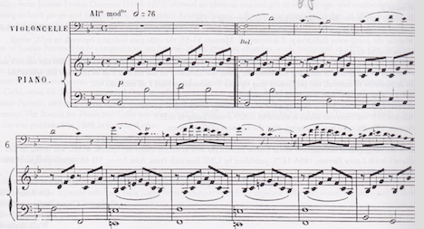

Fig. 2. Ludwig van Beethoven, 1st theme of the Allegro con brio (I) from the
Sonata in D Major for Violoncello and Piano, Op. 102, No. 2
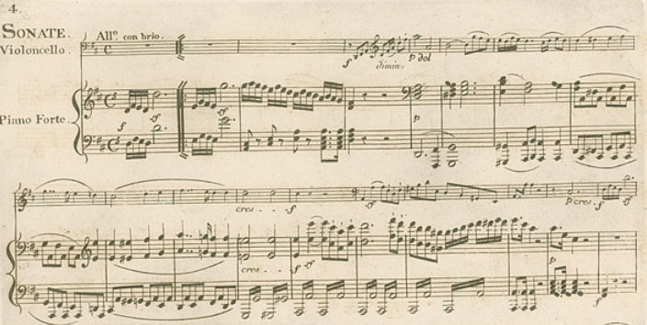
Fig. 3. Anton Reicha, bars 39-44 of the Allegro (I) from the Sonata in G Major for Flute and Piano, Op. 54. (Compare the tremolos in the LH with the tremolos in Fig. 2.)
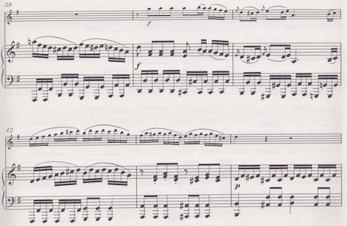

Fig. 4. Louise Farrenc, final bars of the Allegro moderato (I) from the
Sonata in B-flat Major, Op. 46. (Compare this ending with Fig. 5.)
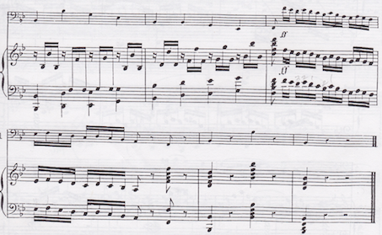

Fig. 5. Ludwig van Beethoven, final bars of the Allegro con brio (I) from the
Sonata in D Major, Op. 102, No. 2. (Compare this ending with Fig. 4.)
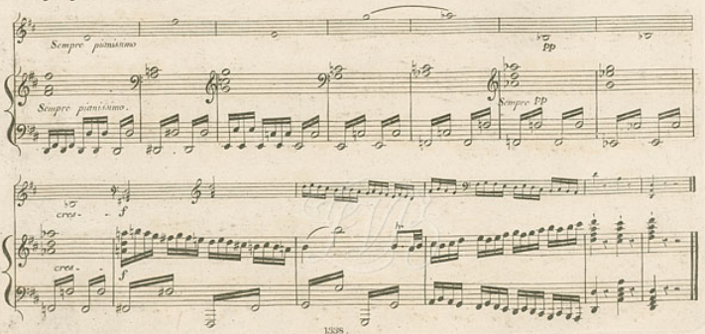
Fig. 6. Anton Reicha, bars 392 – 400 of the Finale-Allegro vivace from the Sonata for Flute and Piano in D Major, Op. 103. (Compare the tremolos in the LH with Fig. 5.)
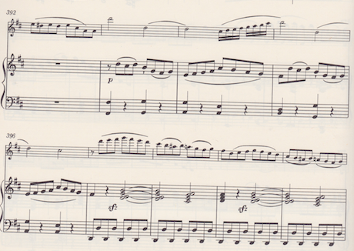

2. Farrenc, Louise. Piano Trios Opus 33 & Opus 34. Nancy Oliveros, Laura Sewell, and Mary Ellen Haupert. Centaur CRC 3435, 2015. CD.
“Both the piano trios featured on this recording, the Piano Trio in E-flat Major, Op. 33 (comp. 1843) and the Piano Trio in D Minor, Op. 34 (comp. 1850-1855), are reminiscent of the music of Beethoven in scope and style. The first trio (Op. 33) is a four-movement work replete with two sonata-form movements (I and IV), a Minuetto, and an inventive slow movement Adagio. ‘Mme. Farrenc’s expressive devices in this Adagio, though fashioned from the common vocabulary of nineteenth-century music, strangely evoke the special flavor of Beethoven’.”

Fig. 7. Louise Farrenc, opening bars of the Adagio sostenuto from the Piano Trio in E-Flat Major, Op. 33. (Compare the expressive writing of Farrenc to Figs. 8 & 9.)
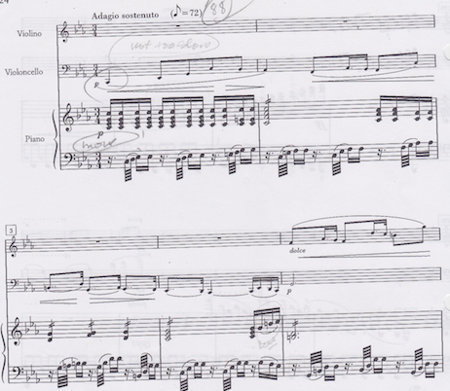

Fig. 8. Ludwig van Beethoven, bars 51-60 of the Adagio cantabile from the Piano Trio in E-flat, Op. 1, No. 1. (Compare the expressive writing of Beethoven to Figs. 7 & 9.)
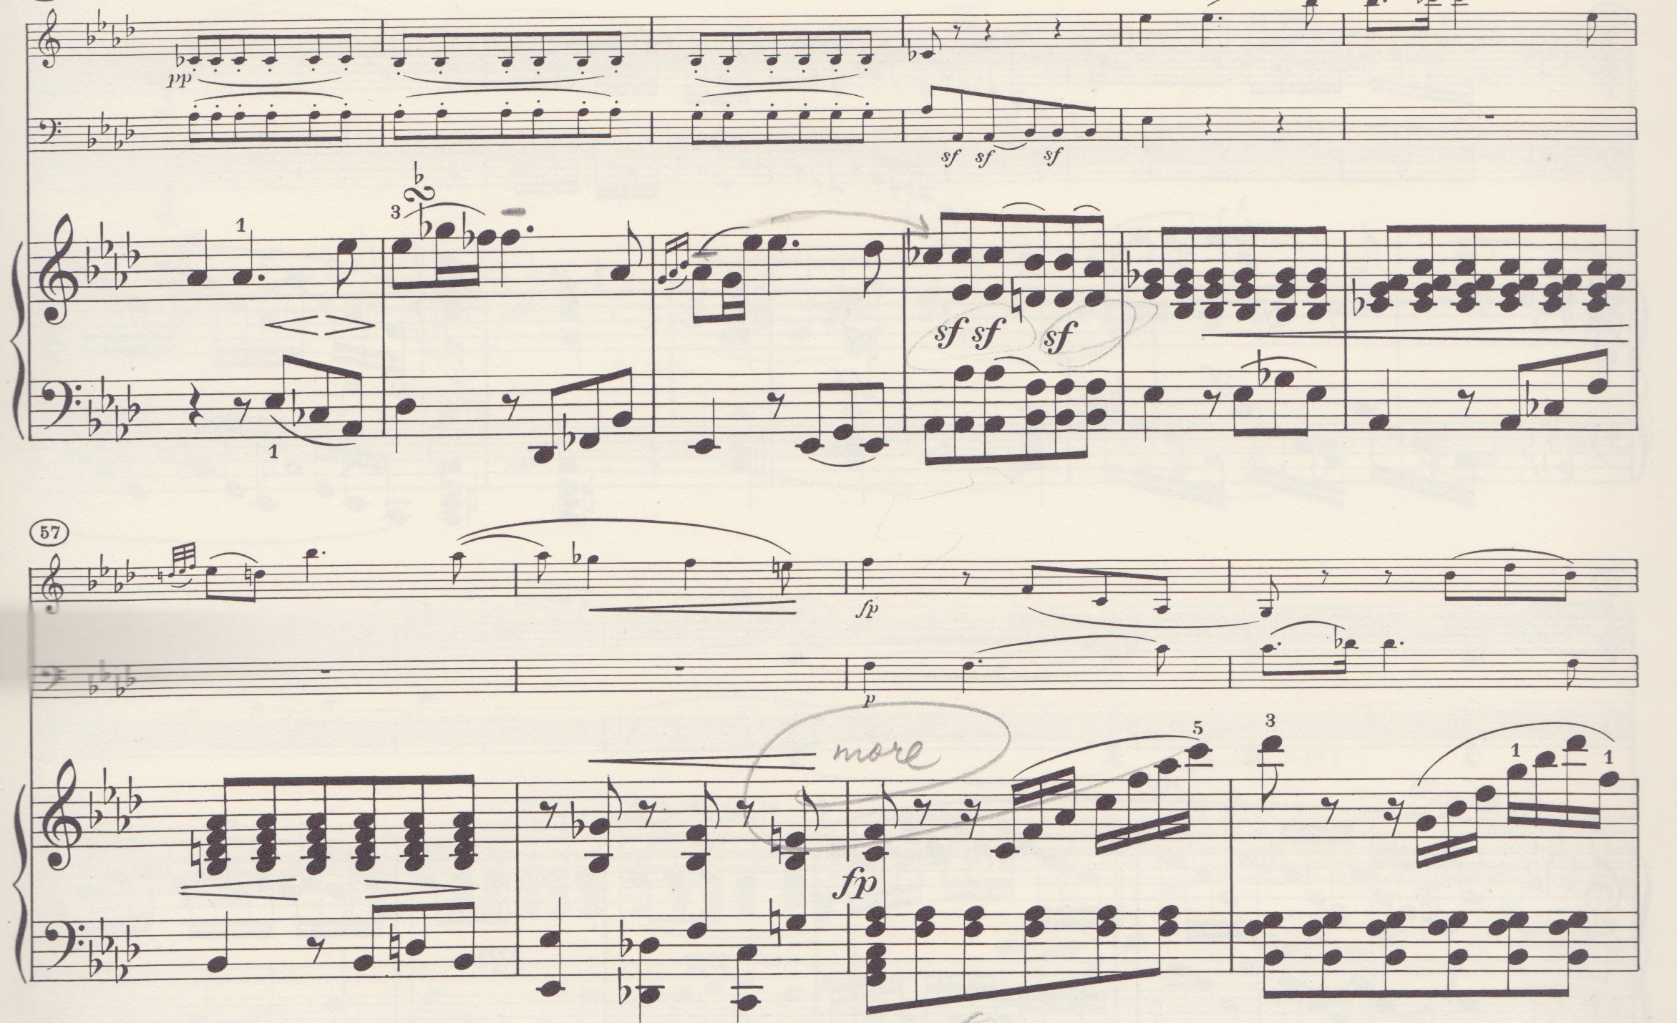

Fig. 9. Anton Reicha, bars 5-13 of the Lento from the Sonata in D Major, Op. 103.
(Compare the expressive writing of Reicha to Figs. 7 & 8.)
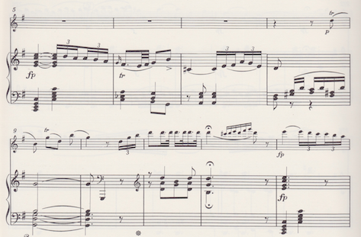

VI. Reicha’s Legacy as a Teacher
Reicha’s contribution to music theory is notable. His four treatises offered composers and musicians some explanation and justification for strict principles, but also gave them permission to be creative with musical elements. A century before Bartók and Dohnányi collected and analyzed folk songs, Reicha was exploring and incorporating folk music phenomena (modality, mixed meters, and microtonal leanings) into his compositions and theoretical writing. Reicha’s didactic works include an anthology of music, treatises on melody and harmony, and instruction for composition stage works:
- Practische Beispiele: ein Beitrag zur Geistescultur des Tonsetzers ... begleitet mit philosophisch-practischen Anmerkungen (1803) – English translation: Practical Examples: A Contribution to the Intellectual Culture of the Composer…Including Philosophical and Practical Notes
- Traité de mélodie (Paris, 1814) – English translation: Treatise on Melody
- Cours de composition musicale, ou Traité complet et raisonné d’harmonie pratique (1818) – English translation: Course of Music Composition…or Complete Treatise of Reasoned Practical Harmony
- L'art du compositeur dramatique (4 vols., 1833) – English translation: The Art of Dramatic Composition

Reicha’s success as a teacher can be measured by the caliber of student he was able to attract. “Reicha had had few composition pupils before 1809, but by 1817 the Count de Sèze, recommending Reicha for appointment to the Conservatoire, could point out that eight of Reicha’s students – probably his friends Baillot, Bouffil, Dauprat, Garaudé, Guillou, Habeneck, Rode and Vogt – already were professors there. These men, most of them accomplished musicians when they began studying with Reicha, spread his reputation for being precise, logical, efficient and strict.”

More impressive than the Conservatoire nobility, Reicha attracted notable composers Franz Liszt, Hector Berlioz, and Cesar Franck into his studio – all of whom lauded Reicha’s teaching. In 1832, Adam Liszt would choose Anton Reicha as one of two private teachers for his talented son Franz. Alan Walker, in his exhaustive biography of Franz Liszt, describes the attraction to Reicha’s innovative writing: “Some of [Reicha’s] works contain advanced harmonic combinations and are unusual also for their display of innovatory metres, characteristics which would later be taken up by the young Liszt.” Hector Berlioz, who studied with Reicha at the Conservatoire from 1826 to 1828, made special mention of Reicha in his memoirs: “Reicha taught counterpoint with remarkable clarity; he made me learn a great deal in a short time and with few words. As a rule he did not omit, as the majority of teachers do, to give to his students, as far as possible, the reasons for the rules whose observance he recommended.” Finally, Cesar Franck’s father moved his entire family in 1835 to Paris so that his son could study privately with Anton Reicha.

Anton Reicha’s legacy as teacher may well have been his most important contribution to the music of the Romantic era. Reicha’s innovative work with some of the world’s most gifted composers has been largely dismissed by music historians; the omission is a gross oversight when one considers his early training and relationship with Beethoven, as well as his compelling theoretical writing. If notable composers benefited from their study with Anton Reicha, it is safe to assume that Louise Farrenc improved her craft under his tutelage, as well. And just as Reicha fails to receive any credit for the success of Liszt, Franck, and Berlioz, he is scarcely mentioned as one of Louise Farrenc’s teachers. We need to retrench our history, and give due credit to Reicha for Treatise on Melody (1814) and Course of Musical Composition (1818), which were the texts used in his composition lessons and Conservatoire theory courses.

VI. Concluding Remarks
Anton Reicha’s thoughtful pedagogy contributed to the development of a whole generation of composers. His teaching was the right balance of encouragement and practical technique, especially for the timid, self-effacing Louise Dumont Farrenc who, “in spite of the approbation of her teacher and other professionals aware of her talent, required constant prodding and gentle encouragement.” Reicha nurtured Louise Farrenc’s admiration for Mozart, Haydn, Beethoven, and their contemporaries; his association with Joseph Haydn, studies with Neefe, Albrechtsberger and Salieri, and friendship with Ludwig van Beethoven gave Farrenc direct and invaluable access to the Viennese Classical Style.

As a woman, Louise was barred from the Conservatoire composition classes, but more than likely benefited from a learning environment with Reicha at the center. This included some of the Romantic Era’s most esteemed composers – Liszt, Franck, and Berlioz. Most likely, she was as aware of Liszt, Franck, and Berlioz, as they were of her. Bea Friedland notes that Farrenc was rapidly gaining reputation for her piano variations (Aire russe varie, Op. 17 – 1835), citing reviews in Robert Schumann’s Neue Zietschrift für Musik (1836) and Maurice Bourges’ La Revue et gazette musicale (1840). Reputable composers would have been aware of her accomplishments, especially those living in Paris and studying with Anton Reicha at the time of the Schumann review which was just prior to his death.

Anton Reicha was a philosopher who quoted Aristotle and Kant to his pupils. He may have been strict and diligent, but cultivated an impressive level of creativity and critical thinking among his students. Sir Ken Robinson, a contemporary British advocate for educational reform, has argued that [contemporary] school systems have squelched creativity in the classroom with standardized testing, no end to mind-numbing worksheets, and useless memorization – all measures that tap into only a fraction of human capability. The result of this is that education, which should enliven minds and nourish creative potential, has been reduced to a dead-end regurgitation of facts and figures, rather than a means by which students learn to be life-long contributors in any given discipline.

An excerpt form Reicha’s Treatise on Melody bears insight into his teaching, as well as the sort of students who sought him out:
“The genius for musical composition is only a favorable natural aptitude for this art. It manifests itself, (1) through a great passion for music, (2) through a burning need to create (that is, to compose) and to exploit what one has done, (3) through a great capacity to conceive and realize ideas, (4) through a keen and profound feeling for this art, judgment of which is prompt and accurate whenever applied, this being the most salient requirement for music. With these characteristics it is easy to recognize this kind of genius. A big distinction must be made between genius and talent. Talent is acquired at the cost of strict, assiduous, painstaking application, and must furthermore be well directed. A superior talent is a most rare gift. Genius without talent amounts to little and often comes to nothing. Genius is more common than one thinks, and as Voltaire has aptly said: It walks the streets.”

Reicha taught his students to innovate, while writing music that was both skillful, but extraordinarily unique. One only has to listen to the works of Liszt, Franck, Berlioz, and Farrenc to note his/her own unique style. Anton Reicha was the very best brand of teacher because he helped to unlock each composer’s voice, while humbly ceding his role in the face of his students’ accomplishments. As part of Anton Reicha’s prodigious legacy, Louise Farrenc became the first female piano professor at the Paris Conservatoire, was a published and respected composer, and worked alongside her husband in their music publishing business. She was an accomplished pianist who wrote fetching music in the Viennese Classical tradition, establishing herself as one history’s great female musical personalities.

Bibliography

Anderson, Emily, Ed. The Letters of Beethoven, Volume I. New York: St. Martin’s Press, Inc., 1961.

“Antonin Reicha,” Norman Demuth, Music & Letters, Vol. 29, No. 2 (Apr., 1948), pp. 165-172.

Berlioz, Hector. Memoirs of Hector Berlioz from 1803 to 1865, Comprising His Travels in Germany, Italy, Russia, and England. Trans. Rachel Holmes and Eleanor Holmes. New York: Tudor Publishing Co., 1932.

Demuth, Norman. Cesar Franck. New York: Philosophical Library, 1949.

Farrenc, Louise. Deux Sonates de Chambre. Mary Ellen Haupert, Nancy Oliveros, and Kirsten Whitson. Centaur CRC 4271, 2012. CD.

Farrenc, Louise. Piano Trios Opus 33 & Opus 34. Nancy Oliveros, Laura Sewell, and Mary Ellen Haupert. Centaur CRC 3435, 2015. CD.

Friedland, Bea. "Farrenc." Oxford Music Online. Oxford University Press, accessed August 7, 2017, http://www.oxfordmusiconline.com/subscriber/article/grove/music/09336pg2.

Friedland, Bea. Louise Farrenc, 1804-1875: Composer, Performer, Scholar. Ann Arbor: UMI Research Press, Studies in Musicology, 1980.

Fux, Johann. Gradus ad Parnassum (1725). New York: Dover.

Holoman, D. Kern. “The Paris Conservatoire in the Nineteenth Century.” Oxford Handbooks Online. 3 Nov. 2017. http://www.oxfordhandbooks.com/view/10.1093/oxfordhb/9780199935321.001.0001/oxfordhb-9780199935321-e-114.

Marek, George. Biography of a Genius. New York: Funk & Wagnalls, 1969.

McCachren, Jo Renee. Anton Reicha’s Theories of Musical Form. UMI Dissertation Information Service: Ann Arbor, MI, 1991.

Peter Eliot Stone. "Reicha, Antoine." Oxford Music Online. Oxford University Press, accessed August 3, 2017, http://www.oxfordmusiconline.com/subscriber/article/grove/music/23093.

Reicha, Anton. Treatise on Melody. Trans. Peter M. Landy. Hillsdale, NY: Pendragon Press, 2000.

Rice, John A. History of Music: Beethoven, Reicha, and the Eroica. Web, accessed August 7, 2017, https://sites.google.com/site/johnaricecv/beethoven-reicha-and-the-eroica.

Robinson, Ken. Creative Schools: The Grassroots Revolution That’s Transforming Education. New York: Penguin Random House, 2015.

Swafford, Jan. Beethoven: Anguish and Triumph. New York: Houghton Mifflin Marcourt Publishing Company, 2015.

Turner, W.J. Berlioz: The Man and His Work. London: J.M. Dent and Sons LTD., 1939.

Walker, Alan. Franz Liszt: The Virtuoso Years, 1811 – 1847. Ithaca, NY: Cornell University Press, 1983.

J.G. Prod'homme, and Theodore Baker. "The Baron De Trémont: Souvenirs of Beethoven and Other Contemporaries." The Musical Quarterly 6, no. 3 (1920): 366-91. http://www.jstor.org/stable/737966.

Anton Reicha (1770 - 1836) was a Bohemian (Czech) composer who was active in France and Austria. He was of particular importance as a theorist and teacher in early 19th-century Paris.
Bea Friedland. Louise Farrenc, 1804-1875: Composer, Performer, Scholar. Ann Arbor: UMI Research Press, Studies in Musicology, 1980, p. 77.
Ibid, p. 51.
Johann Nepomuk Hummel had great influence on Louise Farrenc’s education and artistic development. In addition to being her private piano instructor, he gave her husband Aristide Farrenc exclusive French rights to publish all of his works in 1825. Without ignoring Hummel’s significance in Farrenc’s career, the scope of the paper is limited to the influence of Reicha.
Friedland, Louise Farrenc, p. 14.
…to musicologist and publisher Aristide Farrenc (1794-1865).
Bea Friedland. "Farrenc." Grove Music Online. Oxford Music Online. Oxford University Press, accessed August 7, 2017, http://www.oxfordmusiconline.com/subscriber/article/grove/music/09336pg2.
Peter Eliot Stone. "Reicha, Antoine." Grove Music Online. Oxford Music Online. Oxford University Press, accessed August 7, 2017, http://www.oxfordmusiconline.com/subscriber/article/grove/music/23093.
Friedland, Louise Farrenc, p. 10.
Richard Taruskin and Christopher Gibbs. The Oxford History of Western Music. Oxford: Oxford University Press, 2013, p. 574.
Peter Eliot Stone, Oxford Music Online, “Reicha.”
Johann Fux’s Gradus ad Parnassum (1725) was the most prominent treatise on counterpoint in the early 18th century. Written as a dialogue between master and student, the book is a study of the vocal polyphonic style of the 16th century, notably that of Palestrina. Fux’s method is based on a series of species that guides the student through rules of counterpoint. Haydn used the book to teach both himself and his students the art of counterpoint. (He assigned the species exercises to Mozart and Beethoven, which are preserved.) It is interesting to note that while C.P.E. Bach described his father’s counterpoint as “dry and wooden,” the skill required to write a fugue was considered necessary foundation to all other forms of composition.
Peter Eliot Stone, Oxford Music Online, “Reicha.” – “The French army’s four-month blockade of Leipzig effectively cancelled his performance. He finally returned to Vienna, but in 1808, when Austria once again prepared for war, he left for Paris, to be welcomed home by Louis Adam and Sébastien Erard.”
Peter Eliot Stone, Oxford Music Online, “Reicha.”
Jan Swafford. Beethoven: Anguish and Triumph. New York: Houghton Mifflin Marcourt Publishing Company, 2015. Swafford quotes Alexander Wheelock Thayer’s formidable and definitive biography of Beethoven. He introduces his latest Beethoven biography (xiii): “This book is a biography of Beethoven the man and musician, not the myth. To that end I have relegated all later commentary to the endnotes. I want the book to stay on the ground, in this time, looking at him as directly as possible as he walks, talks, writes, rages, composes.”
Jan Swafford, Beethoven, p. 100.
Emily Anderson. The Letters of Beethoven, Volume I. New York: St. Martin’s Press, Inc., 1961, pages 82 – 83.
John A Rice. History of Music: Beethoven, Reicha, and the Eroica. Web, accessed August 7, 2017, https://sites.google.com/site/johnaricecv/beethoven-reicha-and-the-eroica. Rice theorizes that Reicha was offended by Beethoven’s criticism of his 36 Fugues and the two of them didn’t speak with one another after 1802.
J.G. Prod'homme, and Theodore Baker. "The Baron De Trémont: Souvenirs of Beethoven and Other Contemporaries." The Musical Quarterly 6, no. 3 (1920): 366-91. http://www.jstor.org/stable/737966.
Richard Taruskin, Oxford History of Western Music, p. 470.
The 1808 trip back to Paris was permanent. Antoine Reicha became a naturalized citizen in 1829.
Holoman, D. Kern. “The Paris Conservatoire in the Nineteenth Century.” Oxford Handbooks Online. 3 Nov. 2017.
Habeneck was a student of Anton Reicha. See Peter Eliot Stone , Oxford Music Online, “Reicha.”
Ibid, p. 12.
Ibid, p. 13.
Bea Friedland, Louise Farrenc, p. 11.
Ibid., p. 36.
Ibid., p. 15. The endnotes of Friedland’s biography of Louise Farrenc bear information regarding the aforementioned publications by A. Farrenc of Beethoven’s work. Friedland makes reference to the Revue musicale IV (1829): 612-13, noting that Farrenc called attention to two fine engravers assigned to the “master’s compositions.” The following footnote explains that the G Major Trio (slated for composition in the same announcement) first appeared in print 50 years later in an edition by Breitkopf and Härtel.
Farrenc, Louise. Deux Sonates de Chambre. Mary Ellen Haupert, Nancy Oliveros, and Kirsten Whitson. Centaur CRC 4271, 2012. CD.
Farrenc, Louise. Piano Trios Opus 33 & Opus 34. Nancy Oliveros, Laura Sewell, and Mary Ellen Haupert. Centaur CRC 3435, 2015. CD.
Farrenc – Liner Notes from CD Recording 2012. It is interesting to note that as we rehearsed the Sonata for Cello and Piano, Kirsten Whitson (the cellist on the recording) made special mention of the similarities between the Farrenc and Beethoven’s Sonata in D Major, Op. 102, No. 2.
Farrenc – Liner Notes from CD Recording 2015.
Soon after his appointment at the Paris Conservatoire, his Cours de composition musicale (1818) was selected as the official harmony textbook for the conservatory’s theory courses. His “Musical Composition Course” explained melodic and harmonic principles, but emphasized practice over theory, thereby encouraging innovation and experimentation. “That Beethoven and Reicha were thinking along the same lines is hard to deny; but the extent to which they influenced each other is harder to guage, partly because the dating of much of Reicha's music is uncertain.”
Peter Eliot Stone , Oxford Music Online, “Reicha.”
Alan Walker, Franz Liszt: The Virtuoso Years, 1811 – 1847. Ithaca, NY: Cornell University Press, 1983, p. 94.
W.J. Turner, Berlioz: The Man and His Work. London: J.M. Dent and Sons LTD., 1939, p. 58.
Bea Friedland, Louise Farrenc, p. 14.
Ibid., p. 17.
Norman Demuth, Cesar Franck. New York: Philosophical Library, 1949, p. 16.
Sir Ken Robinson. Creative Schools: The Grassroots Revolution That’s Transforming Education. New York: Penguin Random House, 2015. There is a wealth of material on the market that is challenging school systems to scrap memorization and standardized testing and embrace project-based learning, which is less broad, but deeper and more meaningful. Other writers on the subject include Ted Dintersmith, Tony Wagner, Ken Robinson, Daniel Pink, and others.
Anton Reicha, Treatise on Melody. Trans. Peter M. Landy. Hillsdale, NY: Pendragon Press, 2000, p. 6.

